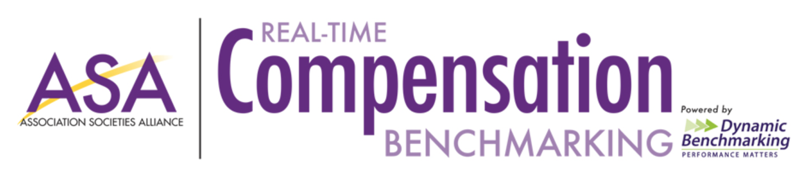

EMAIL MARKETING CAMPAIGN SCHEDULE:
Option 1- Dynamic Benchmarking Sends Emails with Direct Links to Prioritized Question Groups
11/16/21: Data Collection Launch Email Prioritizing Your Association Question Group
11/30/21: Reminder Email Prioritizing Executive Office and Finance Positions Question Group
12/7/21: Reminder Email Prioritizing Marketing & Communication Positions Question Group
12/14/21: Reminder Email Prioritizing Education & Meetings Positions Question Group
1/4/22: Reminder Email Prioritizing Membership & Other Positions Question Group
1/11/22: Reminder Email Prioritizing Benefits & Other Insurance Question Group
1/18/22: Results Launch Email Targeting those that Have Met Progress Threshold and Those that Have
Not.

Option 2- SAE Promotes Benchmarking and Sends Emails Through Their Marketing Portal

11/16/21: Data Collection Launch Email with Content of Your Choice
11/30/21: Reminder Email with Content of Your Choice
12/7/21: Reminder Email with Content of Your Choice
12/14/21: Reminder Email with Content of Your Choice
1/4/22: Reminder Email with Content of Your Choice
1/11/22: Reminder Email with Content of Your Choice
1/18/22: Results Launch Email with Reminder for Those that Have Yet to Participate

SUGGESTED EMAIL COPY:

ASA Email/Social Campaign Suggestions
1st Email in the Sequence:
Subject:
Compensation Metrics for [Association Name]
Content:
Hi [First Name]-
(Button with Link to Sign Up for Platform- https://www.portal.dynamicbenchmarking.com/asa-benchmarking-member-sign-up)
We are excited to announce the launch of our Real Time Compensation Benchmarking Project including a Diversity, Equity and Inclusion section. By giving a little, you will GET A LOT!
- Compare your organization's key operational metrics to others across the industry.
- Evaluate valuable KPI's, including salaries, benefits, positions/departments, and more!
- Generate customized reports and graphs like the below to inform decisions and keep your organization competitive.
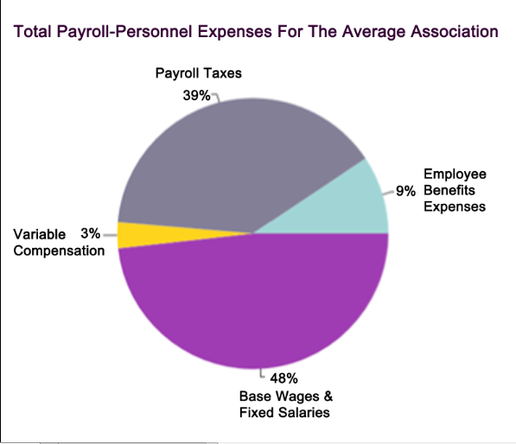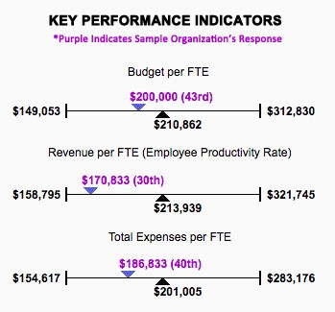
Let’s Get Started:
-Call to Action button for those that have never participated- link to https://www.portal.dynamicbenchmarking.com/asa-benchmarking-member-sign-up
-Call to Action button for those that have participated to https://benchmarking.associationalliance.org/
Corresponding Social Media Post:
-Give a Little, Get A Lot! Enter your data by March 31st to receive reports for free! (Signup Link)

----------------------------------------------------------------------------------------------------------------
2nd Email in the Sequence:
Subject:
63% of Associations Last Year Expected a Revenue Decrease over the next year
Content:
63%
Did you know 63% of you expected a decrease in gross revenue last year?
(Button with Link to Sign Up for Platform- https://www.portal.dynamicbenchmarking.com/asa-benchmarking-member-sign-up)

ENTER YOUR DATA BY MARCH 31ST TO RECEIVE FREE REPORTS
This number and numbers like these are important into understanding where [Association Name] is doing well and where there is room for improvement. By taking the time to enter your data into our Real Time Compensation Benchmarking project, you will help provide important industry stats to help your organization make important business decisions.
Let’s Get Started:
-Call to Action button for those that have never participated- link to https://www.portal.dynamicbenchmarking.com/asa-benchmarking-member-sign-up
-Call to Action for those that have participated to https://benchmarking.associationalliance.org/
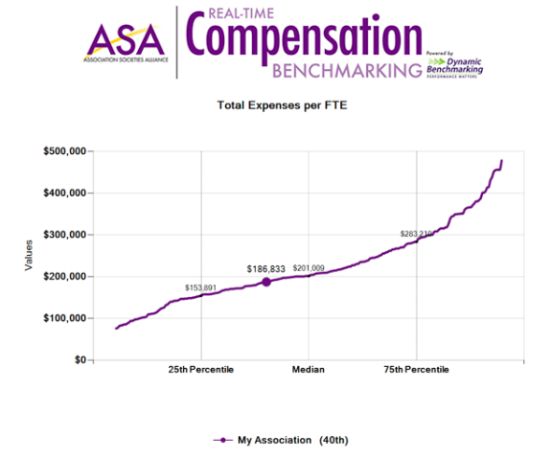
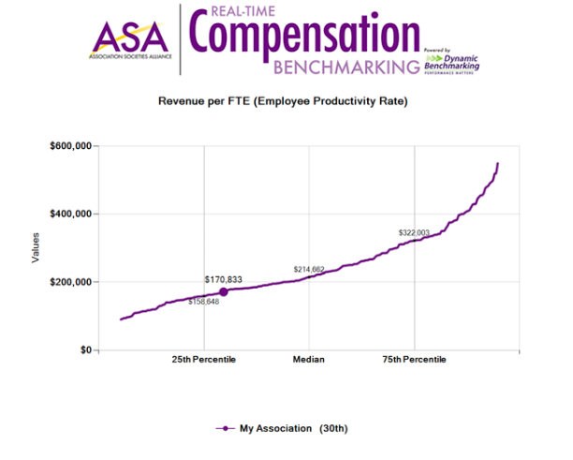
Corresponding Social Media Post:
-Did you know 63% of #associations last year were expecting a decrease in gross revenue over the next year? Where does your organization stack up? Enter data by March 31st for free reports. (link to sign up page)

----------------------------------------------------------------------------------------------------------------
3rd Email in the Sequence:
Subject:
How do you determine where your [Association Name] excels?
Content:
Hi [First Name]-
(Button with Link to Sign Up for Platform- https://www.portal.dynamicbenchmarking.com/asa-benchmarking-member-sign-up)
How many times have you tried to validate decisions, but don’t have the numbers to prove it? Many of us have been in this position when planning budgets, prepping for board meetings or advocating on behalf of our association. The question usually persists:
How do I accomplish this without some type of comparison reporting?
ANSWER: The Real Time Compensation Benchmarking Study is the only 24/7/365 online compensation benchmarking tool designed exclusively for executives of professional, trade and service-centric associations/nonprofits. It allows you to compare your organization's key metrics to others across the industry including metrics like average term of employment:
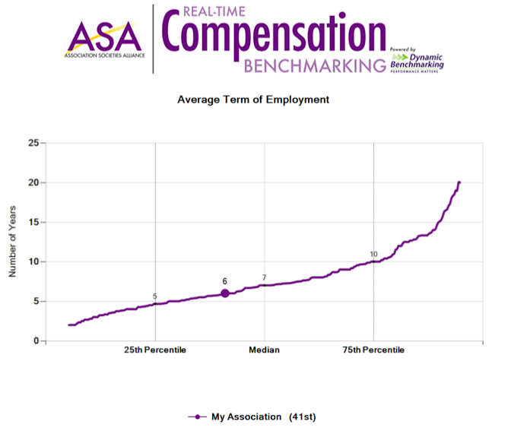
Page Break

Let’s Get Started:
-Call to Action button for those that have never participated- link to https://www.portal.dynamicbenchmarking.com/asa-benchmarking-member-sign-up
-Call to Action for those that have participated to https://benchmarking.associationalliance.org/

Corresponding Social Media Post:
-What tools does your #associaiton use to validate decisions? Nothing compares to good #benchmarking numbers. Participate by March 31st to receive free reports. link to https://www.portal.dynamicbenchmarking.com/asa-benchmarking-member-sign-up

